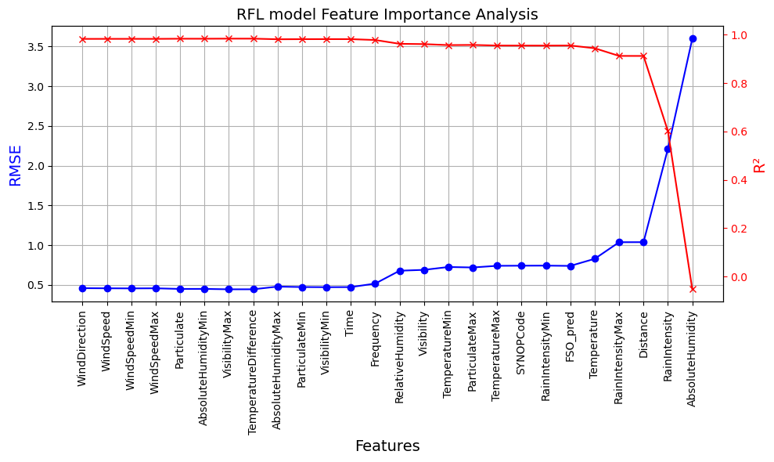

‘RFL_Att’:[‘FSO_pred’,’Temperature’,’RainIntensityMax’,’Distance’,’RainIntensity’,’AbsoluteHumidity’]

‘FSO_Att’:[’ParticulateMin’,’Temperature’,’Visibility’,’Distance’]

